Ernst, Max (1891-1976)

Max Ernst was a painter, sculptor and printmaker. He was born in Germany but lived in Paris, then New York, returning to France in the 1960s. An encounter with Ernst’s work reveals an unconventional frame of reference marked by a ceaseless search for new forms of expression – forms capable of responding to an era of fragmentation and a loss of faith in the Enlightenment ideals of reason and progress. Ernst was an early leader of Dadaism in Cologne and a central member of the Surrealist movement. Indeed, his work is full of intentional contradictions and red herrings, yet it is possible to detect technical and thematic foci throughout his *oeuvre*: birds, forests, petrified cities and the natural sciences. In order to give form to the visions of his unconscious mind, Ernst developed a number of semi-automatic methods of creation: *grattage* (scraping paint from the canvas); *frottage* (taking rubbings); *decalcomania* (a form of image transfer); and *oscillation* (swinging a pierced paint can to drip paint on the canvas).His approach was partly derived from Sigmund Freud’s psychoanalytic theories, an influence shared by the Surrealists Paul Éluard and AndréBreton. Taking war as his primordial experience, Ernst wrestled with multiple forms of expression to produce an extensive and enigmatic body of work that limns the experience of living in a period of bewildering social and political upheaval.

Ernst began as a student of philosophy and psychiatry at the University of Bonn, but soon abandoned formal study to concentrate on painting. In his early period, marked by a friendship with expressionist painter August Macke, Ernst experimented with the styles of the avant-garde and became aligned with The Blaue Reiter [The Blue Rider] group of artists. In 1912, he encountered the work of Paul Cézanne, Paul Gauguin, and Pablo Picasso at the Sonderbund exhibition in Cologne, now known as the first survey of modernist art. This, along with meeting Guillaume Apollinaire (1880-1918) and Jean (Hans) Arp (1886-1966), had an important impact on Ernst. This period of optimism was interrupted by the First World War, in which Ernst served as an Artillery officer. The experience was profoundly traumatic for him.

After the war, as a member of the Dada “anti-art” movement (and influenced by Giorgio de Chircio’s mystical paintings), Ernst began work on his first collages. These assemblages used non-artistic material, but went beyond the Cubist *papier coll*é technique to open up the “collage process…to possibilities that completely transformed its meaning, both technically and ideologically.” In *Sans Titre* (1920), Ernst combines scraps of knitted sweaters with gouache, ink, and crayon to create an abstracted form of two figures set against a landscape of constellations.

After moving to Paris in 1922, Ernst became aligned with the Surrealists. The movement shared the Dadaist distrust of the status quo and developed unconventional techniques in response Freud’s theories of the unconscious and Karl Marx’s revelation of the social subject, which dismantled the integrity of the “self”. After the appearance of the Surrealist Manifesto in 1924, Ernst published *Histoire Naturelle* [*Natural History*]in 1926. The graphic series consists of 34 *frottages* (rubbings) whose methods of production are concealed by the work’s appearance as a scientific illustration. This combination of source materials and techniques continued in *La femme 100 tetes* [*The Hundred Headless Woman,* 1927],the first of three collage-novels.

During the 1920s, the iconographical vocabulary now associated with Ernst had its most prolific period of development: the figure of Loplop, superior of birds, appeared in the early part of the decade, not as a direct representation of the artist but as an aesthetic device. This was followed by the first series of forest paintings using *grattage* (scraping)in 1927.

In the 1930s, these techniques were succeeded by *decalcomania* (transfer of a painted image or pattern from one surface to another) and later by *oscillation* (paint dripping)*.* In addition to experimenting with these semi-automatic processes, Ernst developed an interest in sculpture. As in his collages, works such as *Oedipus I* and *II* combined everyday objects, cast and recast in plaster, to produce perplexing hybrids. In 1941, following the outbreak of war, Ernst left France for New York with the collector Peggy Guggenheim, where he painted *Europe After the Rain II* (1940-42)*.*

After returning to France, Ernst was awarded the Grand Prize for Painting at the 27th Venice Biennale in 1954. Ernst’s acclaim led to international retrospectives at the Museum of Modern Art, New York and the Musée d'Art Moderne, Paris and also to exclusion from the Surrealists. Ernst continued to produce work for varied projects, such as etchings for a German version of Samuel Beckett’s *From an Abandoned Work* and lithographs for Lewis Carroll’s *Wunderhorn*. Ernst died in Paris, leaving behind a body of work that traces a life marked by a continual struggle against a world of disquieting change and the atrocities of the era.

References and further reading:

Bischoff, U. (2004). *Max Ernst, 1891-1976: Beyond Painting.* London: Taschen.

Lippard, L. (1970). ‘Max Ernst: Passed and Pressing Tensions’. *The Hudson Review,* 23 (4): 701-709.

Spies, W. (1991). *Max Ernst: Collages* (trans.) J.W. Gabriel. London: Thames and Hudson.

Spies, W. and Rewald, S. (2005). *Max Ernst: A Retrospective.* New Haven: Yale University Press.

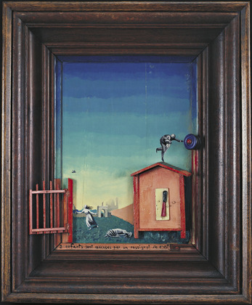

*Two Children Are Threatened by a Nightingale* (1924) <http://www.moma.org/collection/object.php?object_id=79293>

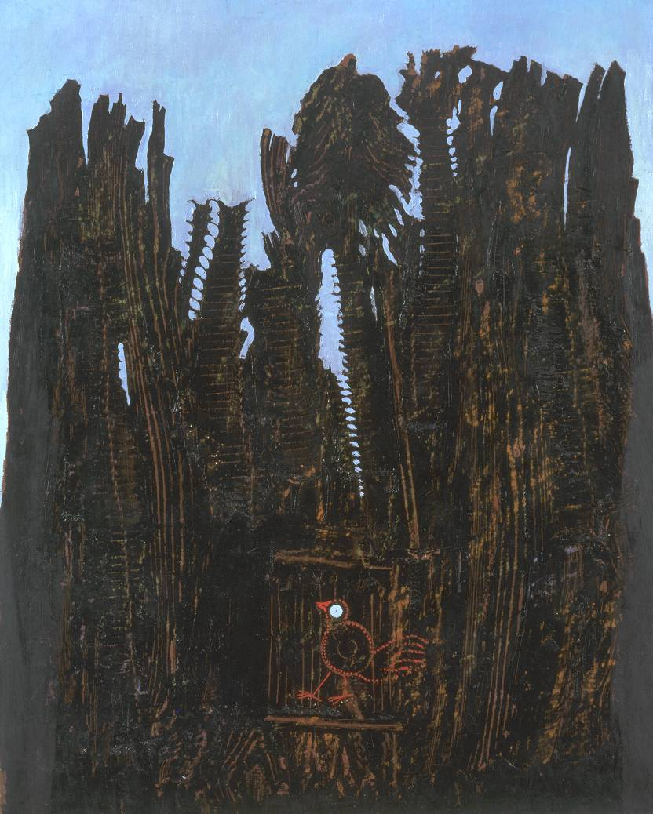

*Forest and Dove* (1927) <http://www.tate.org.uk/art/artworks/ernst-forest-and-dove-t00548>